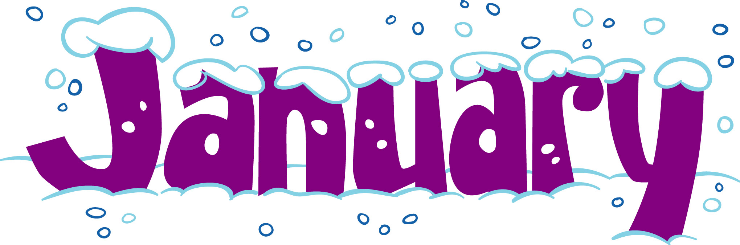

SUNDAY | MONDAY | TUESDAY | WEDNESDAY | THURSDAY | FRIDAY | SATURDAY
 | 1  School Closed for New Year’s Day | 2 | 3 | 4  Chicken Fried Rice  Eggroll | 5  Pizza  Dessert Day – Dessert of the Week or Ice Cream
 | 8  Chicken Nachos  Chicken Taco Salad w/nachos | 9  Spaghetti (Red Only)  Garlic Bread | 10  Chicken Sandwich  Fries | 11  Chicken Strips  Mashed Potatoes  Green Beans | 12  Pizza  Dessert Day Icee or Ice Cream Cup
 | 15  Pancakes & Sausage  Gravy Biscuit | 16  Hamburger  Cheeseburger  Fries | 17  Hot Dog  Chili Dog  Chips | 18  Chicken Fried Rice  Eggroll | 19  Pizza  Dessert Day – Dessert of the Week or Ice Cream
 | 22  Chicken Nachos  Chicken Taco Salad w/nachos | 23  Spaghetti (Red Only)  Garlic Bread | 24  Chicken Sandwich  Fries | 25  Chicken Strips  Mashed Potatoes  Green Beans | 26  Pizza  Dessert Day Icee or Ice Cream Cup
 | 29  Pancakes & Sausage  Gravy Biscuit | 30  Hamburger  Cheeseburger  Fries | 31  Hot Dog  Chili Dog  Chips
Please refer to information given to you regarding lunch orders using the EZ Lunch Program. All lunch orders will be placed by parents/guardians using this new program. Teachers will not be placing lunch orders this year. Lunches must be pre-ordered the day before. You can also pre-order lunches as far in advance as you wish. However, it is you responsibility to cancel or change any orders.

